

Student handbook


Table of Contents
Welcome 3
Placement details 3
What is palliative care? 3
Our strategy 4
Our history 4
Who are we? 5
Your placement 7
The aims of your placement 7
What can you expect? 7
Training and development 7
Shift patterns, policies, and procedures 8
If you are sick 8
Uniform policy 8
Breaks and food 9
Travel 9
Important information 10
How to summon help in an emergency 10
Confidentiality 10
Safeguarding 10
Placement specific workbook 12
Additional Resources 22
Useful websites and reading 23

Welcome
Welcome to Willen Hospice. This handbook contains information to help guide you through your placement, and to give you a clearer understanding of our strategy, our values, and our history.

We hope you enjoy your time with us and find it a valuable and enriching experience.

Whilst you will have been assigned supervisors and assessors, the rest of the Hospice staff are also here to support you and your learning needs. You will be joining a friendly team who all work closely to support each other and support our patients and their relatives.

Placement details
Address: Willen Hospice, Milton Road, Willen Village, Milton Keynes, MK15 9AB.
Telephone: 01908 663636
Website: www.willen-hospice.org.uk

Student
Placement
Practice assessor
Practice supervisor
Practice Development supervisor
Academic assessor
Dates of placement
Please make sure you share your PAD with the named member of the Practice Development Team supervisor.

What is palliative care?
Palliative care is the active, holistic care of patients with advanced progressive illness. Management of pain and other symptoms, and the provision of psychological, social, and spiritual support, are paramount.

The goal of palliative care is the best possible quality of life for patients and their families. Many aspects of palliative care are also applicable earlier in the course of the illness, in conjunction with other treatments.

Palliative care aims to:

- Affirm life and regard dying as a normal process
- Provide relief from pain and other distressing symptoms
- Integrate the psychological and spiritual aspects of patient care
- Offer a support system to help patients live as actively as possible until death
- Offer a support system to help the family cope during the patient’s illness and in their own bereavement

(The National Council of Palliative Care, 2015)

Our strategy
We are committed to continuously reviewing and improving our services. To achieve this, we have a strategic plan and strategic programme milestones that support progressive service delivery and ensure we meet the changing needs of our local population.

Our purpose
To improve the lives of people in our community impacted by a life-limiting illness.
Our mission
We provide outstanding specialist palliative care and wellbeing support to those in our community impacted by a life-limiting illness.
Our vision
A community where anyone can experience the best possible quality of life, however long that life may be.
Our values
Our values define who we are and shape the way we behave. We believe that by embracing our shared values, we can make a meaningful and lasting difference to the community we serve.

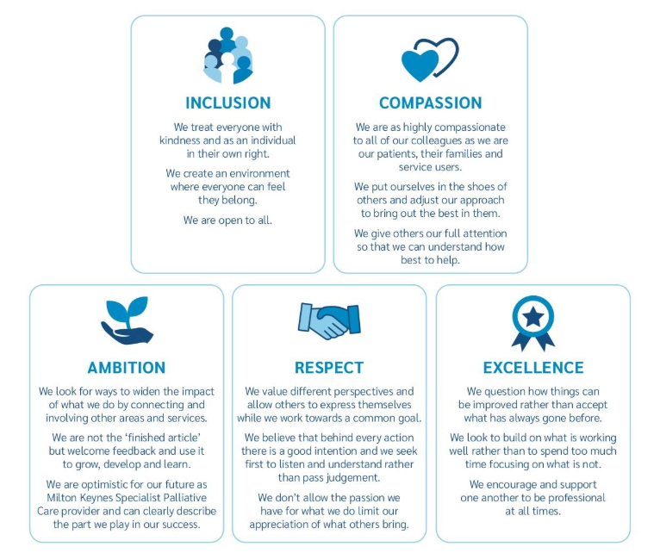

Our history
Willen Hospice was established in the 1970s by people who cared deeply for their local community. Today, we continue to deliver the care we have become so well known for.

You can read more about our history, to understand how we have grown and evolved over the last 50 years to meet the needs of our patients and their families.

Who are we?
It is important that our care is responsive to the needs and choices of our patients. Our support extends beyond the Hospice buildings and into the community.

You will be given the opportunity to work within the In-Patient Unit or Willen at Home teams, as appropriate, to gain knowledge of the role of the multi-disciplinary team involved in palliative care within the local community. We encourage you to spend time with as many different services as you can, including our retail and marketing teams as it is important that you understand how Willen operates as a charity.

In-Patient Unit (IPU): our 15 in-patient beds at the Hospice, where we provide 24-hour specialist, compassionate care, as well as support for patients’ carers and families.

Willen at Home (WAH): our community team of skilled, experienced nurses who have expert knowledge in supporting local people with a life-limiting illness. WAH consists of a range of healthcare professionals: specialist palliative care clinical nurse specialists (CNSs), associate CNSs, registered nurses, and healthcare assistants (HCAs).

Palliative Care Hub: a free 24-hour advice and support line open to any adult with a life-limiting illness who is registered with a GP in Milton Keynes. The Hub is also open to patients’ carers and family members, as well as healthcare professionals. The Hub runs alongside WAH and is a new and evolving service.

Lymphoedema service: our specialist lymphoedema nurses provide holistic, personalised care for patients who have developed swelling secondary to cancer or its treatments, or life-limiting conditions, and patients with a confirmed diagnosis of primary lymphoedema. This team is based at The Well.

Medical team: a consultant-led team specialising in palliative care, who support both the IPU and community teams.

Practice Development team: a team of nurses providing clinical training and education to staff and the local community. This team is based on the inpatient unit.

Therapeutic & Wellbeing service: our wellbeing offering for patients, carers and families is delivered by a group of teams (below). The service’s Living Well programme offers individual and group activities, which mostly take place in the Wellbeing Centre.

Physiotherapy team: help patients build on or maintain their physical strength and activity levels so that they can be more independent and have better wellbeing and quality of life.

Occupational therapy team: help patients achieve independence in activities that are important to them, from getting washed or dressed, to a hobby such as gardening.

Complementary therapy team: offer complementary therapies, such as massage and acupuncture, aimed at reducing anxiety, promoting relaxation, and easing symptoms.

Psychology and counselling team: provide emotional and psychological support to patients, and to their carers/families pre- and post-bereavement.

Social care team: offer support with practical, financial, social, and emotional matters to patients and their loved ones, as well as providing peer support through regular groups and art therapy for adults and children.

Spiritual care team: offer a listening ear through our in-house chaplains, who arrange memorials and other services for palliative patients and their families. The team have contacts with many different faith groups.

Business Development (BD): a collection of fundraising teams who organise events and activities throughout the year to help raise funds for the Hospice. Some teams aim their activities at the public, and some are focused more specifically on local businesses, community groups, major donors or those who might leave us a legacy. BD staff are based at The Well.



Your placement

The aims of your placement
- To experience comprehensive learning in palliative and end of life care (PEOLC) and its management
- To achieve your learning objectives
- To promote your maximum potential
- To understand what is meant by specialist palliative care
- To feel confident in caring for palliative patients with complex needs within the Hospice and community teams

What can you expect?
We offer many different learning opportunities. Some examples are:

- Symptom control
- Assessment of needs
- Communication and listening skills
- Medicines management
- Injection techniques and use of syringe pumps
- Continence management
- Holistic, personalised care
- Oral hygiene
- Clinical skills e.g. wound care, catheterisation
- Importance of psychological and spiritual support
- Future care planning and advance care planning
- Care in the last days of life, in line with the five priorities of care for the dying person
- Care for people after death

This is intended as a guide only and some opportunities may not arise during your placement, while others not listed may be encountered.

You will have access to our intranet, which will allow you to access organisational policies and procedures.

Training and development
We are committed to providing an environment that supports your learning, training, and development. We encourage you to attend in-house training, as well as any appropriate skills training.
You will be provided with an OWL (Our Willen Learning) account at the beginning of your placement, which will give you access to relevant mandatory training. E-learning is also available at www.e-lfh.org.uk., where you can register for a free account and access lots of interesting modules.

The PD team comprises of:
- Lead- Claire Corkill (claire.corkill@willen-hospice.org.uk)
- Nurses- Neel Biswas (neel.biswas@willen-hospice.org.uk ) and Claire Hayzelden (claire.hayzelden@willen-hospice.org.uk)
They are here to support your placement and provide tailored education. Our office is on the IPU, or you can contact us on the email addresses above.

Shift patterns, policies, and procedures
Please come to our main reception on your first day and a member of the team will take you to your placement.

Your shifts will be discussed at your first meeting with your mentor. Please ensure you plan a few weeks of shifts with your lead supervisor in advance, so these can be entered onto our roster system.

General shift patterns are:
IPU
- Day shift: 08.00-20.15 hrs
- Night shift: 20.00-08.15hrs
WAH
- Long day: 08.00-20.00 or 08.00-18.00
Therapists
- Monday-Friday, hours negotiable

If you are sick
If you feel unable to come to your placement on any day that you are rostered to be here, you must call 01908 663636 as soon as you can, to inform your supervisor or the shift leader, and report your illness. You must also inform the university of your absence. If you do not inform us, we will report your absence to the university as unexplained.

Uniform policy
You are expected to adhere to the Hospice’s uniform policy. The main points are:
- Uniforms must be clean and presentable
- Forearms must be uncovered (bare below the elbows)
- Long hair must be tied up, so it does not touch the collar of your uniform
- No necklaces
- Single stud earrings allowed
- One single, plain wedding band only. No other rings
- No nail varnish/long nails
- ID should always be worn

If you feel you should be exempt from an aspect of the uniform policy on religious grounds, please discuss this with your lead supervisor.

Breaks and food
There is a café in the Hospice that is usually open weekdays 08.00-16.00. You need to order lunch at Catering.Requests@willen-hospice.org.uk by 10.00. Meal breaks vary depending on the department you are placed in. There are areas to store your own food within the departments.

Travel
Car parking is available on site, subject to space.

Important information

How to summon help in an emergency
The Hospice does not have a cardiac arrest trolley. In an emergency, dial (9) 999. There is a defibrillator and oxygen in the In-Patient Unit. Please familiarise yourself with where these are located.

Confidentiality
Confidentiality is a fundamental principle in nursing practice and an essential part of maintaining trust between patients and healthcare professionals. As a student nurse, it is your responsibility to protect all personal and medical information shared by patients, whether written, spoken, or electronic. This means only discussing patient details with members of the healthcare team who are directly involved in their care and ensuring that records are stored securely. Breaching confidentiality can damage the nurse-patient relationship, harm the patient, and lead to serious professional or legal consequences. Always remember that maintaining confidentiality demonstrates respect, professionalism, and adherence to the Nursing and Midwifery Council (NMC) Code.

Safeguarding
Safeguarding is a vital part of a nurse’s role and focuses on protecting individuals, especially children, vulnerable adults, and those at risk. As a student nurse, you have both a moral and professional duty to be alert to signs of abuse or neglect and to take appropriate action if you have concerns. This includes recognising physical, emotional, sexual, or financial abuse and following your organisation’s safeguarding policies and procedures to report concerns promptly. Safeguarding is not about making judgments but about ensuring that people receive the support and protection they need. By being vigilant, compassionate, and proactive, you help create a safe environment and uphold the standards of care outlined in the Nursing and Midwifery Council (NMC) Code.

Your wellbeing
You may never have witnessed a death before, and you may have concerns or fears about this and participating in last offices. We are very aware of this and can offer you support. Be honest about your anxiety so we can recognise your concerns and try to support and guide you.

None of us have all the answers about ‘what to say’ or ‘what to do’ in every situation. We rely on our colleagues to help us out all the time. There are lots of emotive issues that both touch and disturb us all whilst working here, and you may well experience this too. If you have suffered a recent bereavement, please talk to us; we are here to support you. You can also discuss this in your clinical supervision sessions.

Not all our patients are in their last days of life. Some may come in for symptom control and go home again. Some may come back again with new problems or return for end-of-life care. With input from WAH, the Hub, community nursing, GPs and palliative care community nurse specialists, many patients can fulfil their wish to be cared for at home.

During your placement, you will have access to online and face-to-face education opportunities, as well as the Hospice intranet. If you feel at any time that you require additional support, such as emotional or educational support, or support for a disability, please speak to either your mentor, the department manager of your area, or a member of the Practice Development team.

You will be expected to work the same shift patterns as your mentor/associate mentor for at least 40% of the time. When they are not on duty, you will be allocated to work with another member of staff. If you require shift changes or have other requests, within reason, you can discuss these with your mentor.

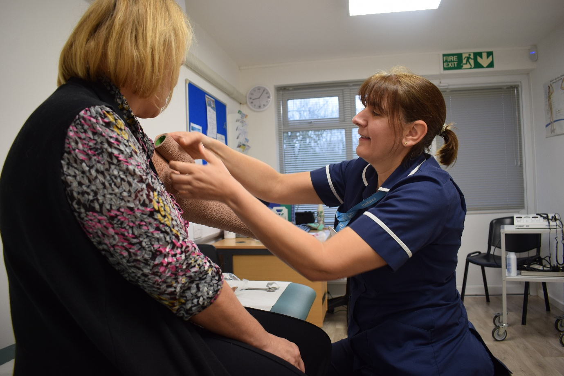

Placement specific workbook

You will be spending time with the Practice Development Team and covering the following areas;
Date

You will also have a weekly supervision session with your Practice Development Team supervisor. These will be arranged on the following dates:
Date

All of the above will be included in your hours. However, failure to complete the required work or failure to attend your supervision sessions or training will mean that hours will be deducted.
During your placement, please arrange to spend half a day in the following areas. This will give you a holistic view of how the Hospice functions.
Date
Fundraising and marketing
Warehouse mel.cox@willen-hospice.org.uk
Lymphoedema team lymphoedema@willen-hospice.org.uk
Therapeutic and Wellbeing Jenni.Marks@willen-hospice.org.uk
Willen at Home Claire.Burr@willen-hospice.org.uk

You are expected to complete the following template for one drug used in PEoLC per week to be discussed in your supervision session.

Week 1
Information
Name of drug
Drug classification
Classification therapeutic uses
Including indications and cautions
Dose range and route(s) of administration
Mode of action
Side effects
Interactions
Absorption
Distribution
Metabolism
Excretion
Cost
Notes

Week 2
Information
Name of drug
Drug classification
Classification therapeutic uses
Including indications and cautions
Dose range and route(s) of administration
Mode of action
Side effects
Interactions
Absorption
Distribution
Metabolism
Excretion
Cost
Notes

Week 3
Information
Name of drug
Drug classification
Classification therapeutic uses
Including indications and cautions
Dose range and route(s) of administration
Mode of action
Side effects
Interactions
Absorption
Distribution
Metabolism
Excretion
Cost
Notes

Week 4
Information
Name of drug
Drug classification
Classification therapeutic uses
Including indications and cautions
Dose range and route(s) of administration
Mode of action
Side effects
Interactions
Absorption
Distribution
Metabolism
Excretion
Cost
Notes

You need to focus on one patient and complete the following by the end of the placement. You will be allocated one shift to undertake your research. You will be expected to discuss this with your Practice Development Team supervisor.
Holistic nursing template in palliative care
Patient Case Study

Patient Diagnosis

Past Medical History

Presenting complaints/ symptoms
- How may their symptoms link to their diagnosis?
- How may their symptoms link to psychological or social factors?
Regular medications
- What are these medications used for?
- Are they appropriate for your patient today e.g. do the medications need rationalising? Is your patient safe to swallow?
PRN medications
- Note the medications prescribed and what they can be used for.
- Note how they are being used to treat for your patient – be mindful some medications can treat more than one
Social factors
- Who is supporting your patient?
- How are families and friends coping?
- What can we do to support loved ones?
- What was life like before IPU admission?
- Is your patient’s goal to go home – if so, what changes and what support needs to be put in place to make this happen?
- What was life like for your patient before they became unwell?
Psychological factors
- Does your patient have any mental health needs?
- How are they coping with their illness and prognosis?
- Are there any factors impacting how they may be feeling?
- What are we doing to support them?
- Is there anything else you can think of that might provide psychological support?
- What services could you sign post them to?
MDT
- Talk to the different professionals involved in your chosen patients care.
- What are the patient’s goals?
- What is each professional doing to achieve them?
- How can we work together?

Handover
- Discuss and engage in reflective conversation with your supervisor.
- Would another nurse be able to confidently care for your patient from the handover you have given?

Reflection
- Reflect on your day and the information you have gained.
- How has this improved your practice?
- Name three things you have learnt about holistic nursing in a palliative care setting?

Developed by Leah Godfrey 10.2025

The following proficiencies should be covered in this placement.
Year 2 proficiencies for the IPU
1. | Support people to make informed choices to promote their well-being and recovery, assessing their motivation and capacity for change using appropriate therapeutic interventions, e.g. cognitive behavioural therapy techniques.
2. | Apply the principles underpinning partnerships in care demonstrating understanding of a person's capacity in shared assessment, planning, decision-making and goal settings.
3. | Recognise people at risk of self-harm and/or suicidal ideation and demonstrates the knowledge and skills required to support person-centred evidence-based practice using appropriate risk assessment tools as needed.
4. | Demonstrates an understanding of the needs of people and families for care at the end of life and contributes to the decision-making relating to treatment and care preferences.
5. | Provides people, their families and carers with accurate information about their treatment and care, using repetition and positive reinforcement when undergoing a range of interventions and accesses translator services as required.
6. | Works in partnership with people, families and carers to monitor and evaluate the effectiveness of agreed evidence based care plans and readjust goals as appropriate, utilising appropriate negotiation strategies, drawing on the person's strengths and assets.
7. | Maintains accurate, clear and legible documentation of all aspects of care delivery, using digital technologies where required.
8. | Makes informed judgements and initiates appropriate evidence based interventions in managing a range of commonly encountered presentations.
9. | Assesses skin and hygiene status and demonstrates knowledge of appropriate products to prevent and manage skin breakdown.
10. | Utilises aseptic techniques when understanding wound care and in managing wound and drainage processes (including management of sutures and vacuum removal where appropriate).
11. | Effectively uses evidence based nutritional assessment tools to determine the need for intervention.
12. | Demonstrates understanding of artificial nutrition and hydration and is able to insert, manage and remove oral/nasal gastric tubes where appropriate
13. | Assess level of urinary and bowel continence to determine the need for support, intervention and the person's potential for self-management.
14. | Insert, manage and remove urinary catheters for all genders and assist with clean, intermittent self-catheterisation where appropriate. Manages bladder drainage where appropriate.
15. | Undertakes, responds to and interpret neurological observations and assessments and can recognise and manage seizures (where appropriate).
16. | Uses contemporary risk assessment tools to determine need for support and intervention with mobilising and the person's potential for self-management.
17. | Effectively manage the risk of falls using best practice approaches.
18. | Uses appropriate safety techniques and devices when meeting a person's needs and support with mobility providing evidence based rationale to support decision making.
19. | Undertakes a comprehensive respiratory assessment including chest auscultation, e.g. peak flow and pulse oximetry (where appropriate) and manages the administration of oxygen using a range of routes.
20. | Uses best practice approaches to undertake nasal and oral suctioning techniques.
21. | Effectively uses standard precaution protocols and isolation procedures when required and provides appropriate rationale.
22. | Provide information and explanation to people, families and carers and responds appropriately to questions about their treatment and care.
23. | Undertakes assessment using appropriate diagnostic equipment in particular blood glucose monitors and can interpret findings.
24. | Undertakes an effective cardiac assessment and demonstrates the ability to undertake an ECG and interpret findings.
25. | Demonstrates knowledge and skills related to safe and effective venepuncture and can interpret normal and abnormal blood profiles.
26. | Demonstrates knowledge and skills related to safe and effective cannulation in line with local policy.
27. | Manage and monitor blood component transfusions in line with local policy and evidence based practice.
28. | Can identify signs and symptoms of deterioration and sepsis and initiate appropriate interventions as required.
29. | Applies an understanding of the differences between risk management, positive risk taking and risk aversion to avoid compromising quality of care and health outcomes.
30. | Demonstrates awareness of strategies that develop resilience in themselves and others and applies these in practice, e.g. solution focused therapies or talking therapies.
31. | Participates in the planning to ensure safe discharge and transition across services, caseloads and settings demonstrating the application of best practice
32. | Negotiates and advocates on behalf of people in their care and makes reasonable adjustments to the assessment, planning and delivery of their care.
33. | Demonstrates effective persons and team management approaches in dealing with concerns and anxieties using appropriate de-escalation strategies when dealing with conflict.
Blue font – years 1, 2 or 3
Red font – years 2 or 3

Year 3 proficiencies for the IPU
1. | Utilises a range of strategies/ resources (including relevant diagnostic equipment) to undertake a comprehensive whole body assessment to plan and prioritise evidence-based person-centred care.
2. | Assesses a persons' capacity to make best interest decisions about their own care and applies processes for making reasonable adjustments when a person does not have capacity.
3. | Actively participates in the safe referral of people to other professionals or services such as cognitive behavioural therapy or talking therapies across health and social care as appropriate.
4. | Recognises signs of deterioration (mental distress/emotional vulnerability/physical symptoms) and takes prompt and appropriate action to prevent or reduce risk of harm to the person and others using for example positive behavioural support or distraction and diversion strategies.
5. | Accurately and legibly records care, with the use of available digital technologies where appropriate, in a timely manner.
6. | Works in partnership with people, families and carers using therapeutic use of self to support shared decision-making in managing their own care.
7. | Manages a range of commonly encountered symptoms of increasing complexity including pain, distress, anxiety and confusion.
8. | Uses skills of active listening, questioning, paraphrasing and reflection to support therapeutic interventions using a range of communication techniques as required.
9. | Is able to support people distressed by hearing voices or experiencing distressing thoughts or perceptions
10. | Manages all aspects of personal hygiene, promotes independence and makes appropriate referrals to other healthcare professionals as needed (e.g. dentist, optician, audiologist).
11. | Manages the care of people who are receiving IV fluids and accurately records fluid intake and output, demonstrating understanding of potential complications.
12. | Manages the care of people receiving fluid and nutrition via infusion pumps and devices including the administration of medicines where required.
13. | Manages and monitor the effectiveness of symptom relief medication, with the use of infusion pumps and other devices.
14. | Manages the care of people with specific elimination needs for example urinary and faecal incontinence and stoma care.
15. | Demonstrates an understanding of the need to administer enemas and suppositories and undertake rectal examination and digital rectal evacuation as appropriate.
16. | Manages the care of people with specific nutrition and hydration needs demonstrating understanding of and the contributions of the multi-disciplinary team.
17. | Demonstrates the ability to respond and manage risks in relation to infection prevention and control and take proactive measures to protect public health e.g. immunisation and vaccination policies.
18. | Understands roles, responsibilities and scope of practice of all members of the multi-disciplinary team and interacts confidently when working with these members.
19. | Effectively manages and prioritises the care needs of a group of people demonstrating appropriate communication and leadership skills to delegate responsibility for care to others in the team as required.
20. | Monitors and evaluates the quality of care delivery by all members of the team to promote improvements in practice and understand the process for performance management of staff (if required)
21. | Actively participates in audit activity and demonstrates understanding of appropriate quality improvement strategies.
22. | Undertakes accurate risk assessments and demonstrates an understanding of relevant frameworks, legislation and regulations for managing and reporting risks.
23. | Participates in appropriate decision-making regarding safe staffing levels, appropriate skill mix and understands process for escalating concerns.
24. | Demonstrates understanding of processes involved in managing near misses, critical incidents or major incidents.
25. | Co-ordinates the care for people with complex co-morbidities and understands the principles of partnership collaboration and inter-agency working in managing multiple care needs.
26. | Evaluates the quality of people's experience of complex care, maintains optimal independence and avoids unnecessary interventions and disruptions to their lifestyle.
27. | Engages in difficult conversations including breaking bad news with compassion and sensitivity.
28. | Facilitates the safe discharge and transition of people with complex care needs advocating on their behalf when required.
29. | Assess and reviews the individual care needs and preferences of people and their families and carers at the end of life, respecting cultural requirements and preferences.

The checklist below is to help you stay on track with your PAD. It is your responsibility to ensure this is completed by the end of your placement.
To complete | Date completed/uploaded
Placement details | ☐
Orientation | ☐
Initial interview | ☐
Professional values in practice (mid-point assessment) | ☐
Mid-point interview (knowledge/skills/attitudes & values) | ☐
Final assessment and reflection | ☐
Final interview (knowledge/skills/attitudes & values) | ☐
Assessors/supervisors  Practice supervisors  Practice assessors  Academic assessors | ☐  ☐  ☐
Patient/service user feedback form | ☐
Working with others | ☐
Record of peer feedback (year 2 and 3 only) | ☐
Assessment of proficiencies | ☐
Professional values in practice | ☐
Episode of care-1 | ☐
Episode of care-2 | ☐
Medicines management | ☐
Worked hours pebble pad | How many………... ☐
Hours filled in on portal each week and submitted | total for this placement………… submitted ☐
Absence | How many hrs……….
Ongoing achievement record | ☐
All pages marked as complete | ☐
End of part (if applicable) | Completed by P/A, A/A

Please download this document and attach to your PAD for evidence of your learning.

Additional resources

www.hospiceuk.org
www.nice.org.uk
www.raredisease.org.uk
www.nmc.org.uk
Transforming hospice care – A five-year strategy for the hospice movement 2017-2022 (Hospice UK, 2017)
Innovation Hub | Hospice UK
Care of dying adults in the last days of life (NICE, 2015)
Overview | Care of dying adults in the last days of life | Guidance | NICE
Professional Guidance on the safe and secure handling of medicines - Royal Pharmaceutical Society (Dec 2018
Recognition for Pharmacy
Care of dying adults in the last days of life (NICE, 2015)
Overview | Care of dying adults in the last days of life | Guidance | NICE
Controlled drugs: safe use and management (2016)
Overview | Controlled drugs: safe use and management | Guidance | NICE
The NHS Long Term Plan (2019)
NHS Long Term Plan
Talking about dying: How to begin honest conversations about what lies ahead (2018)
Resources | RCP
Ambitions for Palliative Care
ambitions-for-palliative-and-end-of-life-care-2nd-edition.pdf

Useful websites and reading

Age UK (2017) [Online] Available from Let’s talk about death and dying (2017)
Cherny et al (2021) Oxford Textbook of Palliative Medicine, 6th Edition
Dahlin C, Coyne P and Ferrell B (2016) Advanced Practice Palliative Nursing, Oxford University Press.
Department of Health (2008). End of Life Care Strategy: promoting high quality care for all adults at the end of life. London: Department of Health. [Online]. Available from: http://www.dh.gov.uk/en/Publicationsandstatistics/Publications/PublicationsPolicyAndGuidance/DH_086277
Department of Health (2016) Our Commitment for you for End of Life. [Online]. Available from End-of-life care commitment (2016)
Dickman A, Schneider (2017) The Syringe Driver: Continuous Subcutaneous Infusions in Palliative Care. 4th Edition. Oxford: Wiley-Blackwell
Hospice UK (2018) Carers Report. [Online]. Available Hospice UK Carers Report (2018)
Leadership Alliance for the Care of Dying People (2014). One chance to get it right: Improving people's experience of care in the last few days and hours of life. [Online]. Available from One Chance to get it right (publishing.service.gov.uk)
Marie Curie 2023 70 years of End-of-life-care in the community. [Online]. Available https://www.mariecurie.org.uk/globalassets/media/documents/policy/policy-publications/2023/1952-report-final.pdf
National Palliative and End of Life Care Partnership (2021) Ambitions for Palliative and End of Life Care 2021 –2026. [Online] available from: ambitions-for-palliative-and-end-of-life-care-2nd-edition.pdf (england.nhs.uk)
NHS England in association with the Palliative Care for People with Learning Disabilities (PCPLD) Network (2017) [Online] Available from Delivering high quality end of life care for people who have a learning disability
Public Health England (2017) Faith at the End of Life. [Online] Available from: Faith at end of life: A resource for professionals, providers and commissioners working in communities (publishing.service.gov.uk)
Wilcock A. Howard P. Charlesworth S. (2022) Palliative Care Formulary: 8th Edition. Pharmaceutical Press

Edu015 Version 3
Author: LW/RH2024

©Willen Hospice 2025. We are a registered charity (number 270194) and a registered company (Willen Hospice Ventures Ltd - number 1231909) in England and Wales.

